For Loop
This tutorial deals with the implementation of a for-loop. The for loop deals with executing the code continuously over a given range of values specified by the user.
In a programming language, the loop means repeating the execution to the instruction or instruction block with respect to the condition specified by the programmer.
Types of loops in Java:
- while loop
- for loop
- do while loop
For-loop
In Java for loop is used to iterate a part of the statement multiple times until a particular condition is satisfied.
Syntax
for (initialization; condition; increment/decrement)
Structure
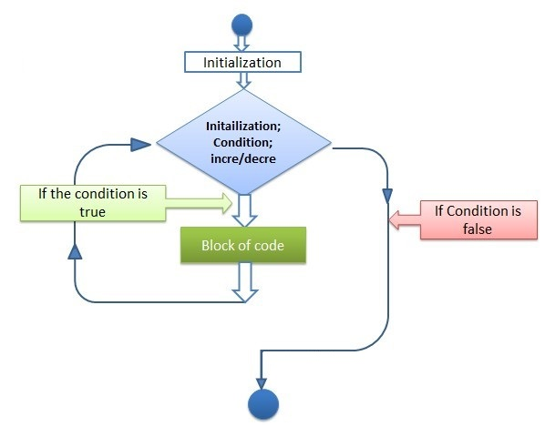
The following program will demonstrate syntax:
In this program int i=1 is initialization value and i<=10 is condition i++ is increment operator.
public static void main(String[] args) {
for (int i = 1; i <= 10; i++) {
System.out.println(i);
}
}
Output:
1
2
3
4
5
6
7
8
9
10

In this program int i=10 is initialization value and i>=10 is condition i– is decrement operator.
public static void main(String[] args) {
for (int i = 10 ; i >= 1; i--) {
System.out.println(i);
}
}
Output
10
9
8
7
6
5
4
3
2
1

Infinite loop
Infinite for-loop is a set of code which repeats itself unless it is forced to stop.
public static void main(String[] args) {
for ( ; ; ) {
System.out.println("Testing text");
}
}
Output:
Testing text
Testing text
Testing text
Testing text
Testing text
Testing text
Testing text
Testing text
Testing text
Testing text
Testing text
Testing text
Testing text
Testing text
Testing text
Testing text

Note: Initialization, condition, increment or decrement are optional.
While Loop
While loop in Java is a structure that executes a statement of code multiple times until the boolean expression is false.
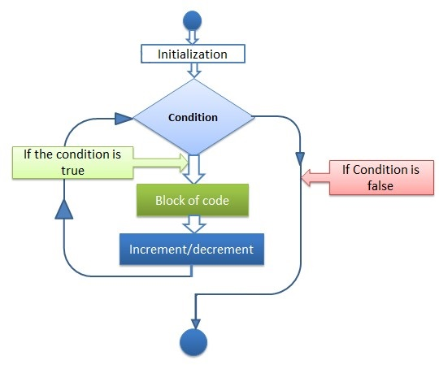
Syntax
while (boolean expression) {
// loop code here
}
In this example, initialize the loop counter “i” with value 1. In the while condition, check whether it is less than or equal to 10 (i=<10), it will print the number in the new line and i++ increment the counter by1. It will print the number repeatedly unless the counter becomes greater than 10.
public static void main(String[] args) {
int i = 1;
while(i<=10) {
System.out.println(i);
i++;
}
Output
1
2
3
4
5
6
7
8
9
10
Infinite loop
In the following example, the boolean expression, that is evaluated before each loop iteration is never modified, so the expression (true) will always evaluate true. The result is, the loop will never end. It is known as an infinite loop.
public static void main(String[] args) {
while (true) {
System.out.println("Infinite loop");
}
Output
Infinite loop
Infinite loop
Infinite loop
Infinite loop
Infinite loop
Infinite loop
Infinite loop
Infinite loop
Difference between for loop and while loop
For loop is used when we know the number of iterations. For example when we are sure that how many times we need to execute a loop.
While loop is used when we are unsure about the number of iteration and want to loop while some condition is true. It will loop that block until the condition is false.
While Loop
It is like filling a bucket with water using a mug. You never know how many mugs of water you use, but only be stopped when the bucket is full.
Work until satisfying a given condition.
For Loop
You were asked to walk for 20 minutes from the given time and you go on walking for the fixed time. There is a beginning and an end, all you need to do is continue your work till the destination is met.
Do While Loop
Java allows you to create a do-while loop, the expression is evaluated at the end of the loop so even if the expression returns false, statements inside the code block will be executed at least once.
Structure
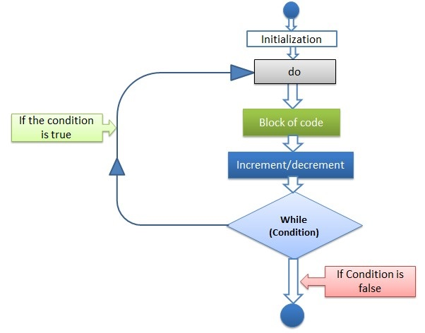
Syntax
do {
// body of loop
} while (condition);

In this statement, the value of i is initialized to 0. Now “do” block prints the value of i then it increments the i by 1, and value will become 1. Then it checks for condition 1<=2 which is true and prints the value of i equal to 1. It will print repeatedly until condition 11<=10 will become false causing the loop to terminate.

public static void main(String[] args) {
int i = 0;
do {
System.out.println(i);
i++;
} while (i <= 10);
}
Output:
0
1
2
3
4
5
6
7
8
9
10
In the following example, Java will execute the block first and then check the loop conditional expression. Although the loop exits immediately, and statement block will be executed once and the program output 11.

public static void main(String[] args) {
int i = 11;
do {
System.out.println(i);
i++;
} while (i <= 10);
}
Output:
11

Note:
Use a while loop when a loop might not be executed at all.
Use a do-while loop when the loop is executed at least once.
Recursion

